SVCC Annual Calendar – 2017
January
7 Men’s Breakfast
8 Children’s Sunday school and ADD Life classes begin
11 Women’s Wednesday Bible study begins
15 Sanctity of Human Life Sunday
29 SVCC Annual Meeting

February
4 Men’s Breakfast
10-11 Elders Retreat
March
4 Men’s Breakfast
12 Daylight Saving Time begins
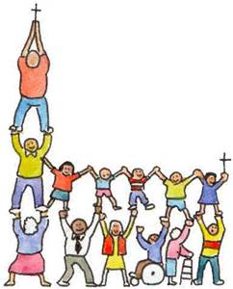
April
1 Men’s Breakfast
7-9 Men’s Retreat, Falls Creek
9 Palm Sunday
16 Easter
May
6 Men’s Breakfast
14 Mother’s Day
21 Last day of children’s Sunday school
24 Last day of women’s Wednesday Bible Study
June
2 Onalaska High School Graduation
3 Men’s Breakfast
10 Mossyrock High School Graduation
18 Father’s Day
July
1 Men’s Breakfast
30 Annual Church Picnic
August
4-6 Mossyrock Blueberry Festival
5 Men’s Breakfast
10-13 Morton Loggers Jubilee
15-20 SWW Fair
27 Home Group Leaders Training

September
2 Men’s Breakfast
10 Children’s Sunday school begins; Fall Semester ADD Life classes begin
13 Women’s Wednesday Bible study begins
20 & 27 Fall Launch of Home Groups
October
7 Men’s Breakfast
13-15 Ladies Retreat, Falls Creek
November
4 Men’s Breakfast
5 Daylight Saving Time ends
12 Day of Prayer for the Persecuted Church
19 Sunday Thanksgiving Service
23 Thanksgiving
December
2 Men’s Breakfast
6 Last day of women’s Wednesday Bible study
10 Christmas Talents Program
24 Candlelight Service
25 Christmas

2/7/2017

